Dynamics and deformability of α-, 3₁₀- and π-helices

Tarun Jairaj Narwani^{1,2,3,4}, Pierrick Craveur^{1,2,3,4}, Nicolas Shinada^{1,2,3,4,5},
Hubert Santuz^{1,2,3,4}, Joseph Rebehmed⁶, Catherine Etchebest^{1,2,3,4}
& Alexandre G. de Brevern^{1,2,3,4,}*

¹ INSERM, U 1134, DSIMB, F-75739 Paris, France.
² Univ Paris Diderot, Univ. Sorbonne Paris Cité, UMR_S 1134, F-75739 Paris, France.
³ Institut National de la Transfusion Sanguine (INTS), F-75739 Paris, France.
⁴ Laboratoire d'Excellence GR-Ex, F-75739 Paris, France.
⁵ Discngine, SAS, 75012, Paris France.
⁶ Department of Computer Science and Mathematics, Lebanese American University, 1h401 2010 Byblos, Lebanon

SUPPLEMENTARY DATA

d1n45a  d1n7ea  d1naza  d1ng6a  d1nkda  d1nkga2  d1nkga3  d1nkia  d1nq7a  d1ntva  d1nyca  d1nyka  d1nyta1  d1nyta2  d1o7ia  d1oboa  d1ogad1  d1oh0a  d1okia2  d1omra  d1ooha  d1p3ca  d1p6oa  d1pkha  d1psra  d1pvma4  d1q1fa  d1q6za2  d1q6za3  d1qfta  d1qh4a1  d1qs1a2  d1r29a  d1r7ja  d1r8sa  d1r8se  d1riea  d1roca  d1rtta  d1s8na  d1saua  d1sh8a  d1shux  d1sjwa  d1szha  d1t1ea2 | d1t2da1  d1t2da2  d1t61a1  d1t61a2  d1t6ua  d1tkea2  d1tp6a  d1tu7a2  d1tu9a  d1tuaa2  d1tzva  d1uaia  d1ucda  d1ui0a  d1urra  d1usca  d1uxza  d1v05a  d1v2xa  d1v30a  d1v37a  d1v4pa  d1v70a  d1v7ra  d1v8ha1  d1vh5a  d1vyia  d1w66a1  d1w7ca2  d1w7ca3  d1wc2a1  d1whia  d1wkqa  d1wlua  d1wmda1  d1wn2a  d1wpna  d1wrma  d1x46a  d1xsza1  d1xsza2  d1y0pa3  d1ypqa1  d1z1sa1  d1z3xa2  d1z6na1 | d1zhva1  d1zi8a  d2nw2b1  d2nw2b2  d2ohwa1  d2oxca  d2piea  d2pmra1  d2pv2a  d2pvba  d2q9oa2  d2q9oa3  d2qjla  d2r7512  d2r8oa1  d2r8oa3  d2rb8a  d2rcqa  d2tnfa  d2tpsa  d2ux6a  d2uyza1  d2v6ka1  d2v6ka2  d2vhka  d2vima  d2w72a  d2wf7a  d2wy4a  d2x4ka  d2x7ka  d2xhfa  d2xola  d2xpwa1  d2y78a  d2yvea1  d2yvea2  d2z3ga  d2zhna  d3mzfa2  d3n4ja  d3n8ia  d3nera  d3ni6a  d3o6wa1  d3obqa | d3od3a2  d3otma  d3p1ga  d3p3ca2  d3p73a2  d3piwa  d3po8a  d3pwka2  d3qfta2  d3qvpa2  d3qzma  d3qzra  d3qzta  d3r3qa  d3rhba  d3rnja  d3ry4a2  d3s4ea  d3tnla1  d3tnla2  d3twya  d3u81a  d3us6a  d3ve9a  d3vl9a  d3vqfa  d3vura2  d3zqxa  d3ztpa  d3zyha  d3zzsa

Supplementary Data 1. Dataset. Provided are the SCOP ids used in the study.

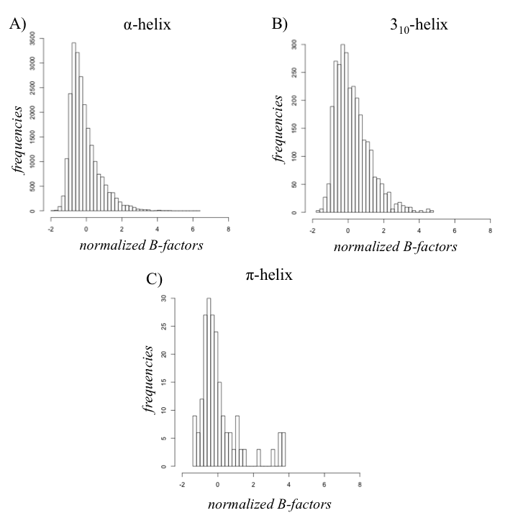

Supplementary Data 2. Normalized B-factor distribution. For A) α-, B) 3₁₀- and C) π-helices.

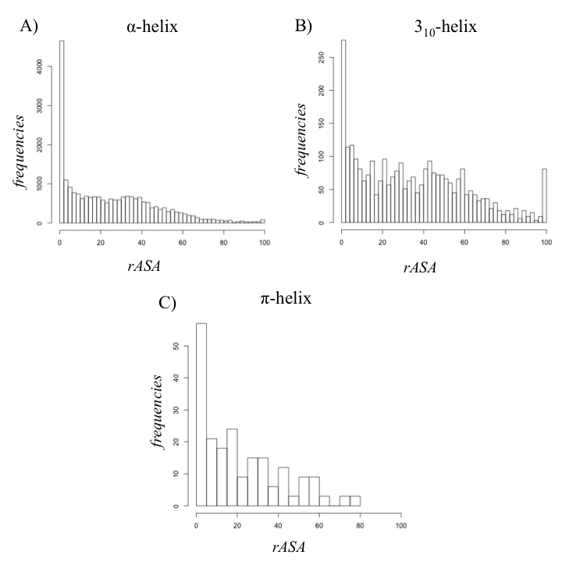

Supplementary Data 3. Relative Solvent Accessibility distribution. For A) α-, B) 3₁₀- and C) π-helices.

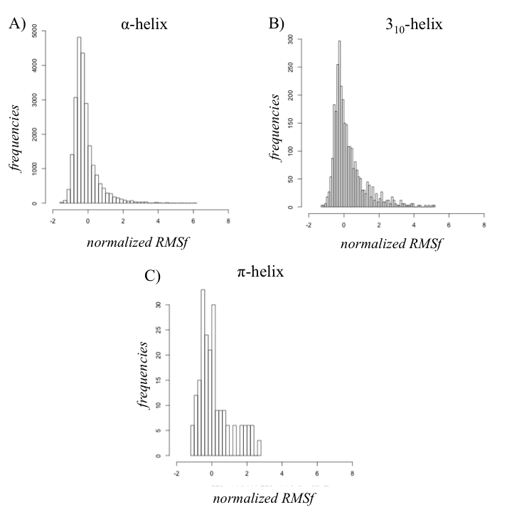

Supplementary Data 4. Normalized RMSf distribution. For A) α-, B) 3₁₀- and C) π-helices.

Initial state | 100% | >90% | >50% | <25%
α-helix | 29.1 | 74.6 | 91.4 | 3.9
3₁₀-helix | 0.0 | 15.7 | 54.1 | 24.0
π-helix | 0.0 | 0.0 | 2.4 | 97.6
π-^{newDSSP}-helix | 0.0 | 15.0 | 39.6 | 38.6

Sup data 5. Persistence of the original helical state. For the three type of helices is shown the frequency of residues staying in the original assigned state (100%) during the simulations with the α–, 3₁₀- and the π-helices (noted π-helices for the classical DSSP assignment and π-^{newDSSP}-helix assigned with DSSP_v2.2.1), the occurrence for those staying more than 90%, more than 50% and less than 25% of the simulation time.

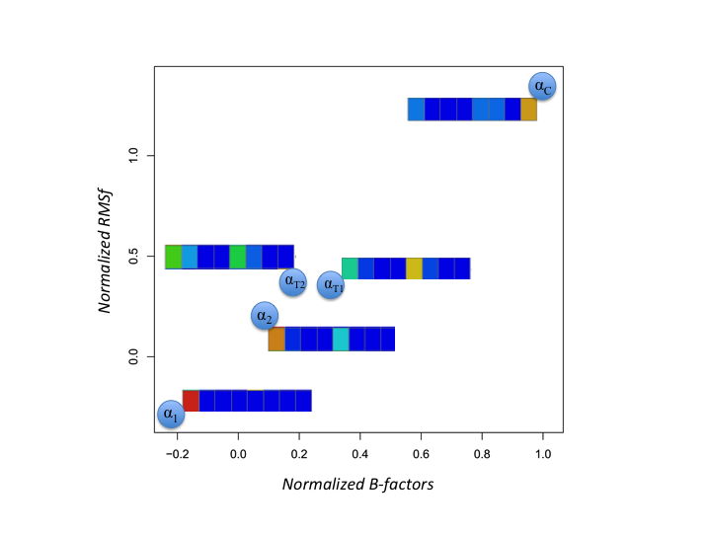

Sup data 6. Analyses of the clusters associated to α-helix. (x-axis) is the normalized B-factors and (y-axis) is the normalized RMSf. The clusters are named in regards to their content in secondary structures (namely α₁, α₂, α_{T1}, α_{T2} and α_{C}). The secondary structures are shown with a gradient of colours ranging from red (100% of presence) to blue (0%). The secondary structures are disposed with α-, 3₁₀- and π-helix, β-strand, turn, bend and coil.

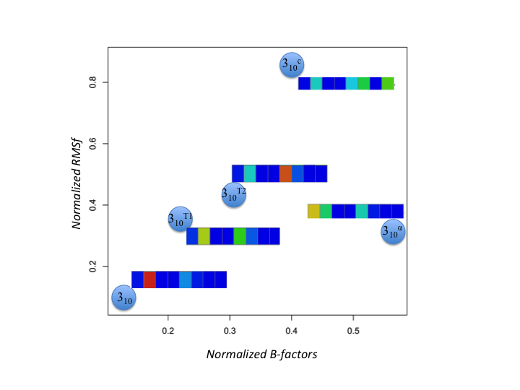

Sup data 7. Analyses of the clusters associated to 3₁₀-helix. The clusters are named in regards to their content in secondary structures (namely 3₁₀, 3₁₀^{α}, 3₁₀^{T1}, 3₁₀^{T2}and 3₁₀^{c}). See Sup data 6 for more details.

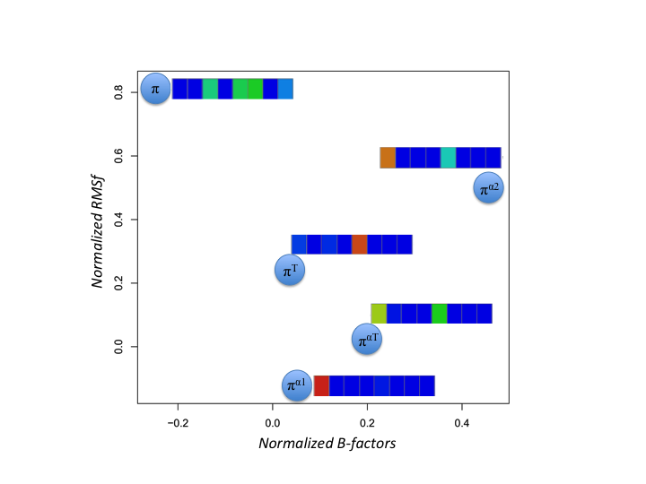

Sup data 8. Analyses of the clusters associated to π-helix. The clusters are named in regards to their content in secondary structures (namelyπ, π^{α1}, π^{α2}, π^{αT} and π^{T}). See Sup data 6 for more details.

